**Practical No. 8**

**Aim -** Design Meaningful Charts & Graphs to Represent Student Academic Performance Data. To create and visualize meaningful charts and graphs using Power BI to represent student academic performance data.

**Theory-** Data visualization is a crucial aspect of data analytics, allowing users to interpret data effectively through graphical representations. Power BI offers a variety of visualization tools, including:

* **Bar Charts**: Used for comparing categorical data.
* **Line Charts**: Suitable for tracking trends over time.
* **Pie Charts**: Displays proportional relationships.
* **Scatter Plots**: Used to identify relationships between two numerical variables.
* **Heatmaps**: Visual representation of data density.

For student academic performance analysis, we can visualize:

* **Subject-wise marks distribution**
* **Comparison of students’ performance**
* **Trend analysis over multiple exams**
* **Overall class performance insights**

**Program-**

**Step 1: Load the Data into Power BI**

1. Open **Power BI Desktop**.
2. Click **Get Data** and select a data source (Excel, CSV, SQL Server, etc.).
3. Select and load the dataset containing student academic records.
4. Click **Transform Data** if any cleaning or preprocessing is required.

**Step 2: Create Visualizations**

1. Navigate to the **Report View** in Power BI.
2. Select the appropriate visualization type from the **Visualizations Pane**.
3. Drag relevant fields into the **Axis, Values, and Legend** sections.
4. Apply filters and sorting options to refine the data presentation.

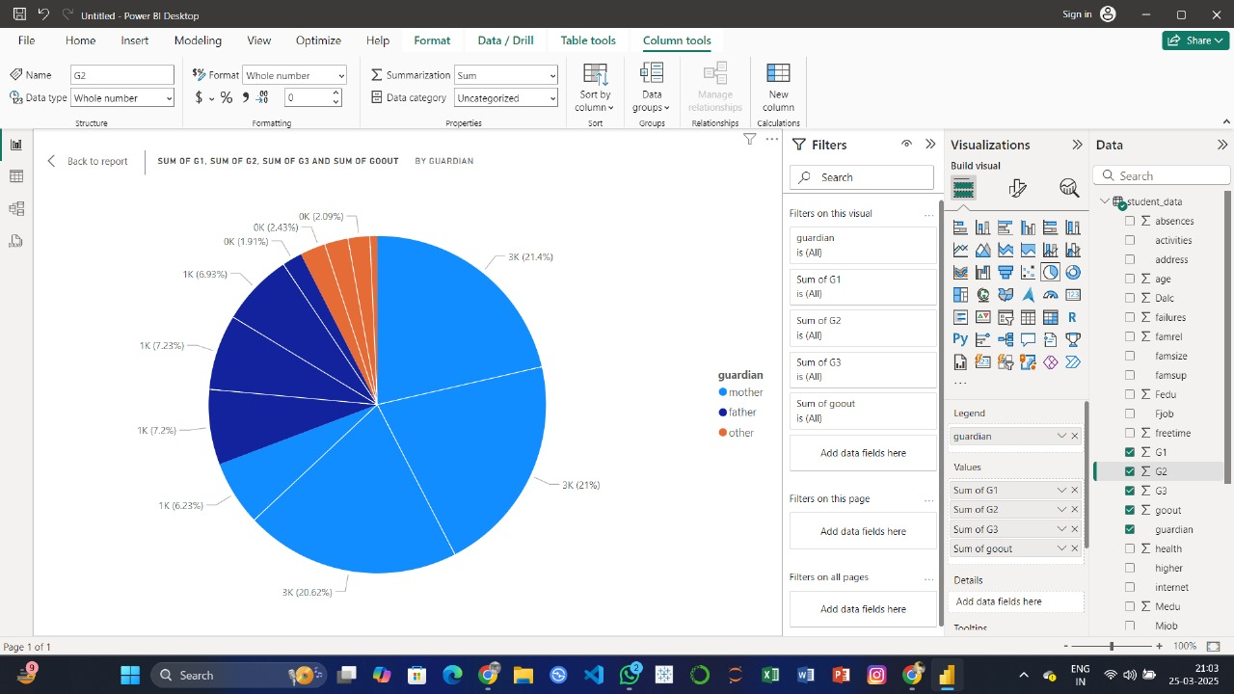

**Step 3: Design Specific Charts**

1. **Bar Chart for Subject-Wise Comparison**
   * Drag **Subjects** to the Axis field and **Marks** to the Values field.
   * Apply a **Clustered Bar Chart** for comparison.
2. **Line Chart for Performance Trends**
   * Drag **Exam Dates** to the X-axis and **Average Marks** to the Y-axis.
   * Apply a **Line Chart** to visualize trends over multiple exams.

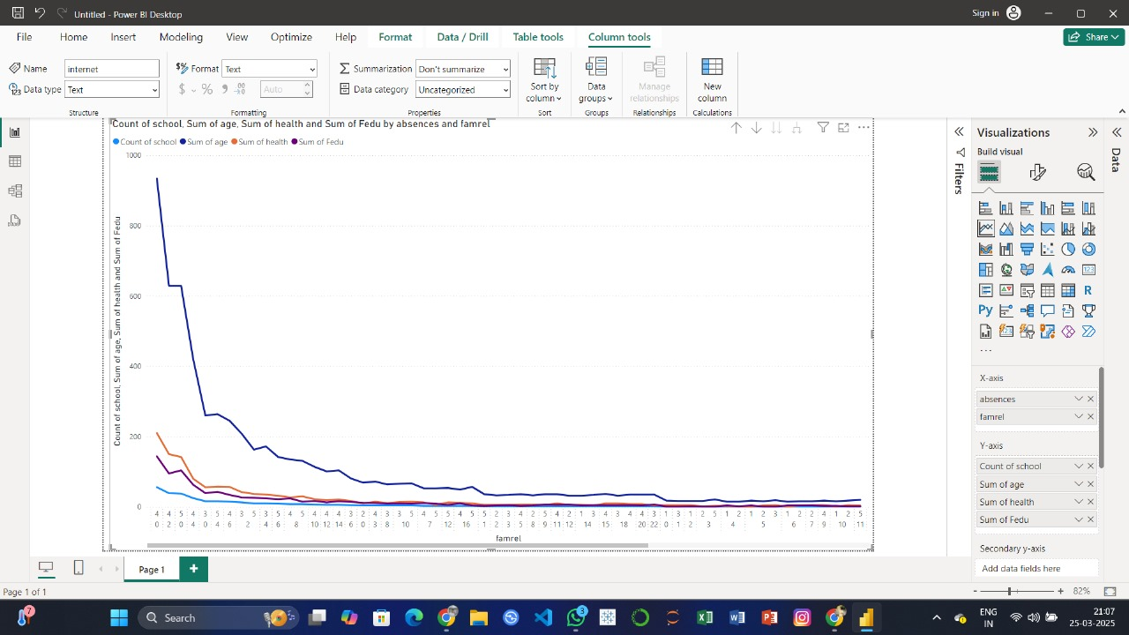

1. **Pie Chart for Grade Distribution**
   * Drag **Grade Categories** and **Count of Students** into a **Pie Chart**.
   * Customize colors and labels for better clarity.
2. **Scatter Plot for Correlation Between Attendance and Marks**
   * Select a **Scatter Plot**.
   * Drag **Attendance Percentage** on the X-axis and **Total Marks** on the Y-axis.

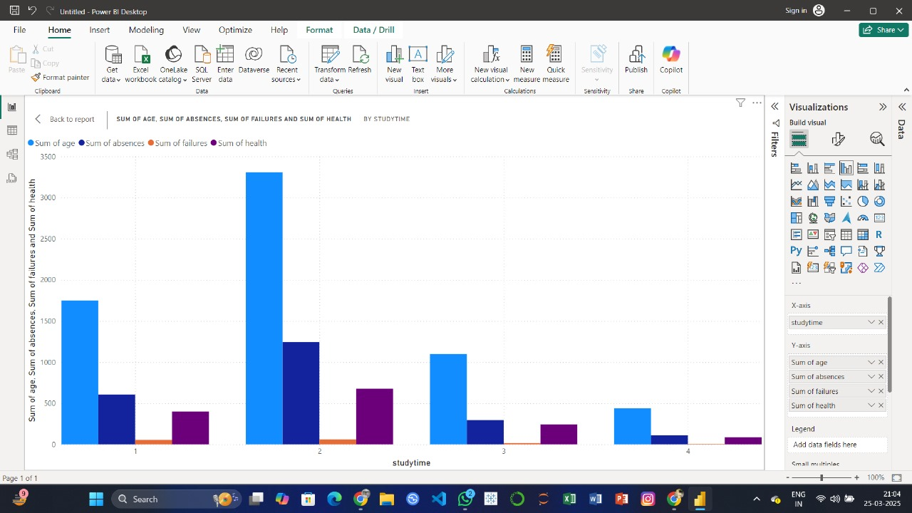

**Step 4: Format and Customize the Visuals**

1. Use **Titles and Labels** for clarity.
2. Adjust **colors and themes** to enhance readability.
3. Apply **data filters and slicers** for interactive analysis.

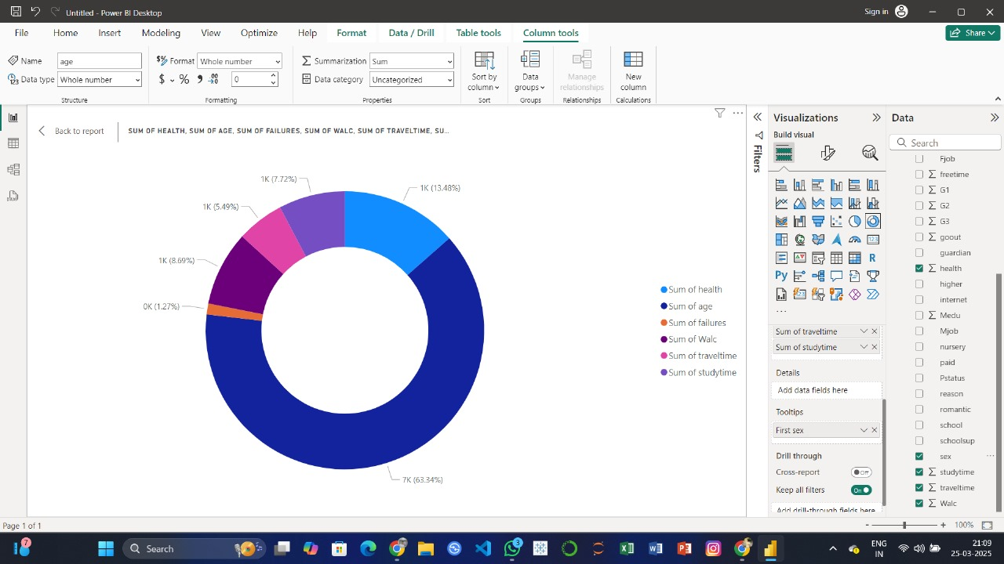

**Conclusion-** In this practical, we successfully designed and visualized academic performance data using different Power BI charts and graphs. The experiment demonstrated the importance of data visualization in interpreting trends and patterns in student performance.